**Q3: Multiplication Table GUI with Tkinter (10 Points)**

**Task:** Implement a Python program using the Tkinter library to create a GUI widget that displays a multiplication table. The table should be a **10x10 grid**, where:

* Rows and columns represent numbers from 1 to 10.
* Each cell displays the product of the corresponding row and column numbers.
* **You must use loops** to dynamically generate the table.

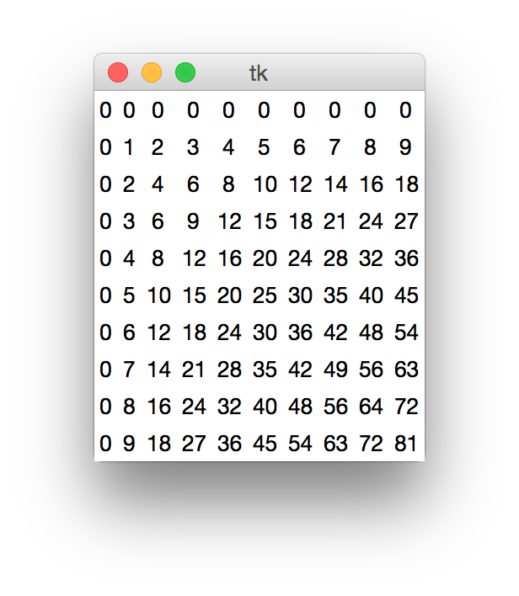

Write the correct code in a Python file named `Q3.py`.

**Marking Rubric (10 Points):**

|  |  |  |
| --- | --- | --- |
| **Criteria** | **Points** | **Description** |
| **Correctness** | 5 points | - Correct implementation of a 10x10 multiplication table. - Each cell displays the correct product. - The table is generated using loops. |
| **Functionality** | 2 points | - The Tkinter window opens and displays the table without errors. - Window title and layout are appropriate. |
| **Documentation** | 1 point | - Code is well-commented, explaining key parts of the implementation. |
| **Code Style** | 1 point | - Code follows Python conventions  - Proper indentation, variable names, and organization. |

**Total: 10 Points**